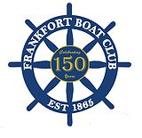
Kentucky River Blast Flotilla
Saturday, June 27, 2015 3pm

BOAT REGISTRATION
Name*_______________________________________________________________________
Email_____________________________________________Telephone*_________________
Mailing Address*_______________________________________________________________
City, State, Zip*_______________________________________________________________
Boat Name__________________________________________________________________
Size*______________________________________________Type*______________________
Theme (if determined at registration) ______________________________________________
Return this completed form by:
Dropping off at the Frankfort Boat Club Café
301 Wapping St. (Head Boat)
OR by US Mail: Frankfort Boat Club
PO Box 89
Frankfort, KY 40602
OR By Email attachment: frankfortboatclub1865@gmail.com

You will be assigned a parade number that corresponds with the order in which your entry is received.
By officially entering the Frankfort River Blast Flotilla, I hereby fully understand and agree that my participation is voluntary and at my own risk. I hereby agree to hold harmless the Frankfort River Blast Flotilla presented by the Frankfort Boat Club for any personal injury or property damage which I may cause in any way, or which may be occasioned to me, those on my vessel or my vessel.

Signature* ________________________________________Date *________________________________
* Indicates required field

PRIZES
26’ and above
1st Place
2nd Place
3rd Place
- Boat entries must complete the parade route and obey parade rules to be eligible for prizes. Each boat can only win one prize.
- Registrations received by Thursday, June 25 will be entered in a drawing to win 10 gallons of gas from the Frankfort Boat Club.

Under 26’
1st Place
2nd Place
3rd Place

RULES AND PROCEDURES
- Vessel must be pre-registered and carry a Flotilla Vessel ID Number on the Starboard side forward.
- A mandatory check-in will be held at the Frankfort Boat Club on the day of the event from 12:00 to 1:00. All vessels must sign-in. Additional directions will be given at that time.
- Staging area for parade participants is above the Capital Avenue Bridge.
- Parade line-up will begin no later than 2:00 p.m. Participants should be prepared to cast off at 2:15 p.m.
- Travel at a continuous “no wake” speed. Stay within 100 feet of the boat in front of you.
- No spins or turns anywhere on parade route. Please keep a steady speed. Route takes approximately 20-30 minutes.
- Parade route will proceed downstream from the Capital Avenue Bridge until passing the judging stand at River View Park and then take a westward turn heading back upstream under the railroad bridge.
- The judges’ reviewing stand will be located at River View Park. Captains should bring their vessels within 100 feet of the reviewing stand but do not stop/turn/spin.
- Parade is not complete until all vessels have cleared both West Frankfort Connector Bridges heading back upstream.
- Please use common sense, be respectful of other parade participants, and be respectful of other boaters. Be safe, have fun and enjoy the parade. Thanks for making it happen!

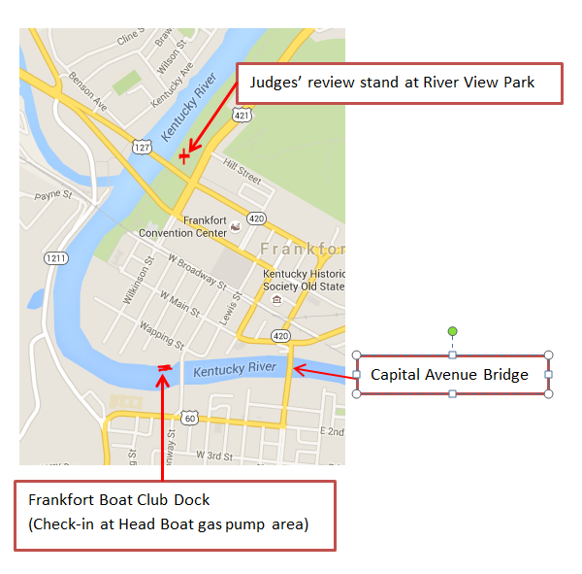
Contact Information:
Tom Mathews (502) 352-0525
Stan Salchli (502) 320-1002
Karen Mixson (502) 330-0169

